Baseline Studies
And Habitat Mapping

We are involving locals / fisheries community / users of natural resources to establish selected Baseline and Habitat Mapping.

Baseline studies are required to establish the state of the environment against which future change may be measured. Baseline studies often require measurement of physical, chemical and biological parameters. Habitat maps are often required to assist with planning, either for a development or for resource management purposes (e.g. marine protected areas).

We have experience in surveying terrestrial / coastal / marine communities (including infauna, seaweed, seagrass beds, mangroves and coral reefs, as well as fishes, turtles, cetaceans, seabirds and other wildlife), terrestrial communities (flora and fauna), seawater quality (including total suspended solids, turbidity, temperature, salinity, nutrients, heavy metals and a wide range of other pollutants), meteorology, air quality (polluting gases including NOx and SOx, and particulates); and noise levels (Leq, Lmax).

Where necessary we consult expert taxonomists for detailed determination of ecological results. We outsource mapping services to specialist firms who use the latest image processing and GIS software and add value ourselves with extensive ground-truthing and image interpretation. We are also experienced in gathering social and economic data through rapid and participatory rural appraisal that has the added benefit of improving awareness of the development among the local communities.

As we plan to equip our facilities with the best in class equipments for sampling and analysis of environmental parameters in Timor Leste and this would take time we meanwhile have in place tie up with environmental laboratories.

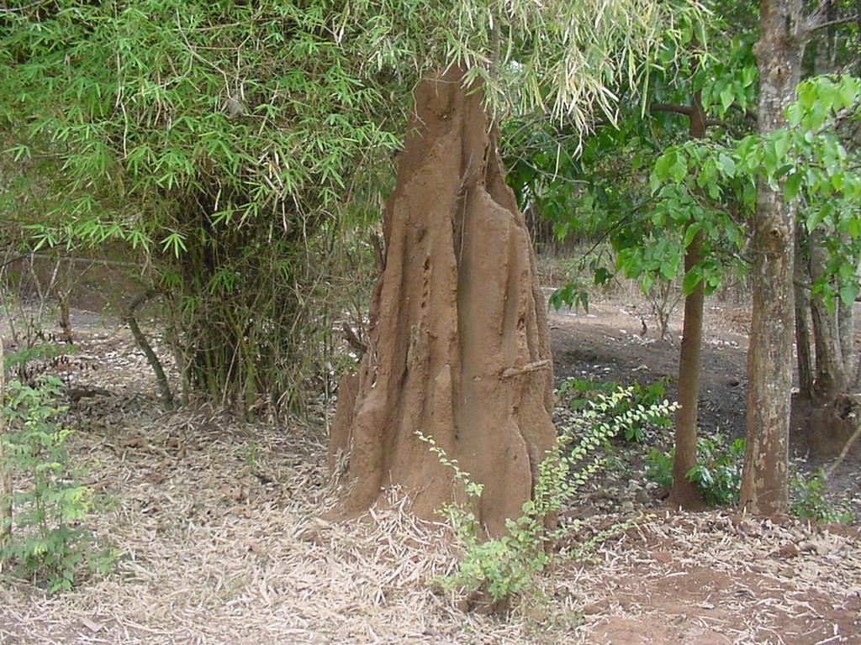
EIAs and

